# Digital to Physical

## Game Premise

The game premise was to make a board game based upon the Pokémon video game series the game would include capturing Pokémon as well as evolutions.

# Rules

* At the start each player plays rock, paper scissors for who chooses first.
* Players will then choose their starting Pokémon card. The starting Pokémon are Charmander, Squirtle, Bulbasaur and Pikachu
* They will then take it in turns rolling a D6 dice to move around the board, moving either forwards or backwards through their current zone (players choice)
* If the player lands on a poke-ball space, they can attempt to catch a Pokémon rolling two D6 dice and combining the total if it is above 10 then they may choose a Pokémon to catch
* Landing on an arrow space allows the player to move to the space the arrow is pointing to
* Landing on the battle zone means all players must roll a D6 adding +1 for each Pokémon they have whoever rolls the highest wins the game

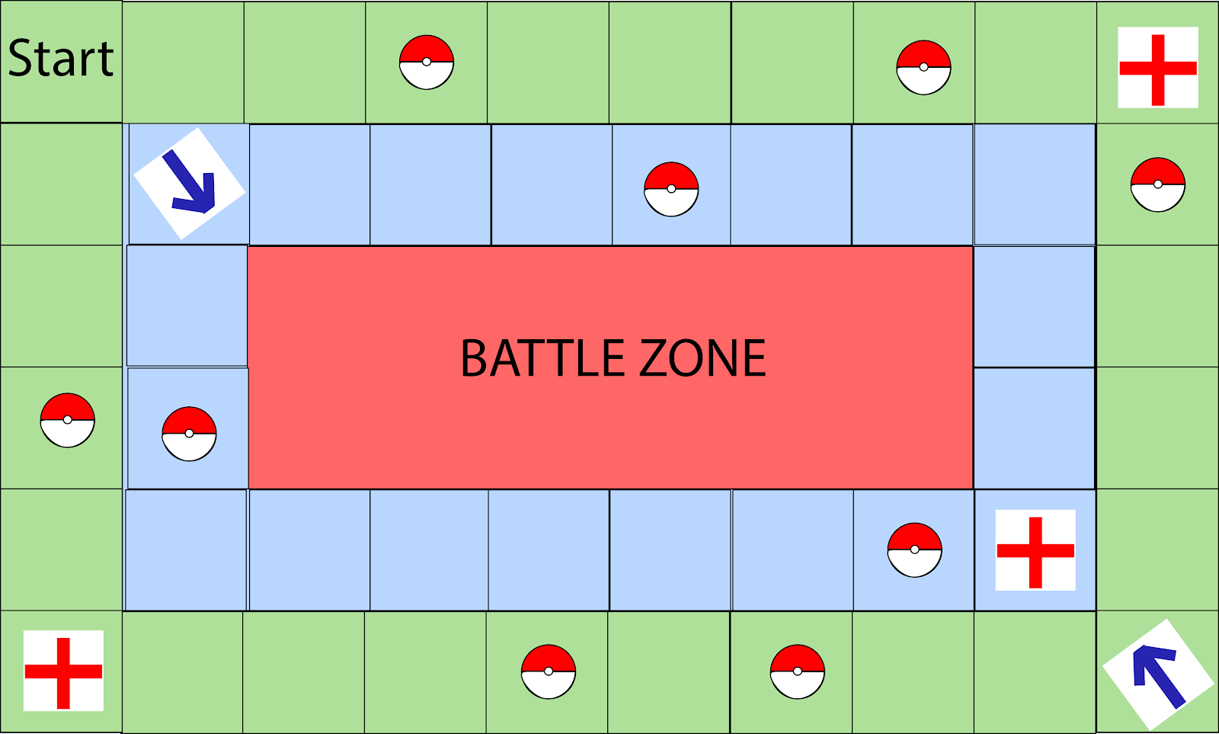

Figure 1: Game Board, A-Player start location, B-Pokeball space, C-Pokemon center space, D-Zone move space

## Playtesting

The feedback we got from playtesting was that the rules were too complex to understand within the short time frame allocated for testing this made the game confusing for new players however the play tester said “Without the time constraints, it would be easier to understand”.

## Teamwork

One team member had not played the Pokémon games before and this slowed development as they had to be explained the concept before production began although this was a set back it was helpful to have someone without experience of the game to see if the game would appeal to non-Pokémon players

## Improvements

One improvement to the game would be changing the rules to achieve greater clarity

Another improvement would be to either focus on battling or capturing Pokémon but not both this would allow greater depth in the game mechanics

## Team Members

Developers: Jamie Smith, Cory Arnett-O’Brien, Rowan Noble

Testers: Sienna Jenkins